Informatica Activity:

Objective: To design workflow such that the max price and min price of the specific cars needs to be calculated and move to target database from the source database.

In the below for the source, selected the mysql database connection, and selected the ‘cars’ table, which was a source table.
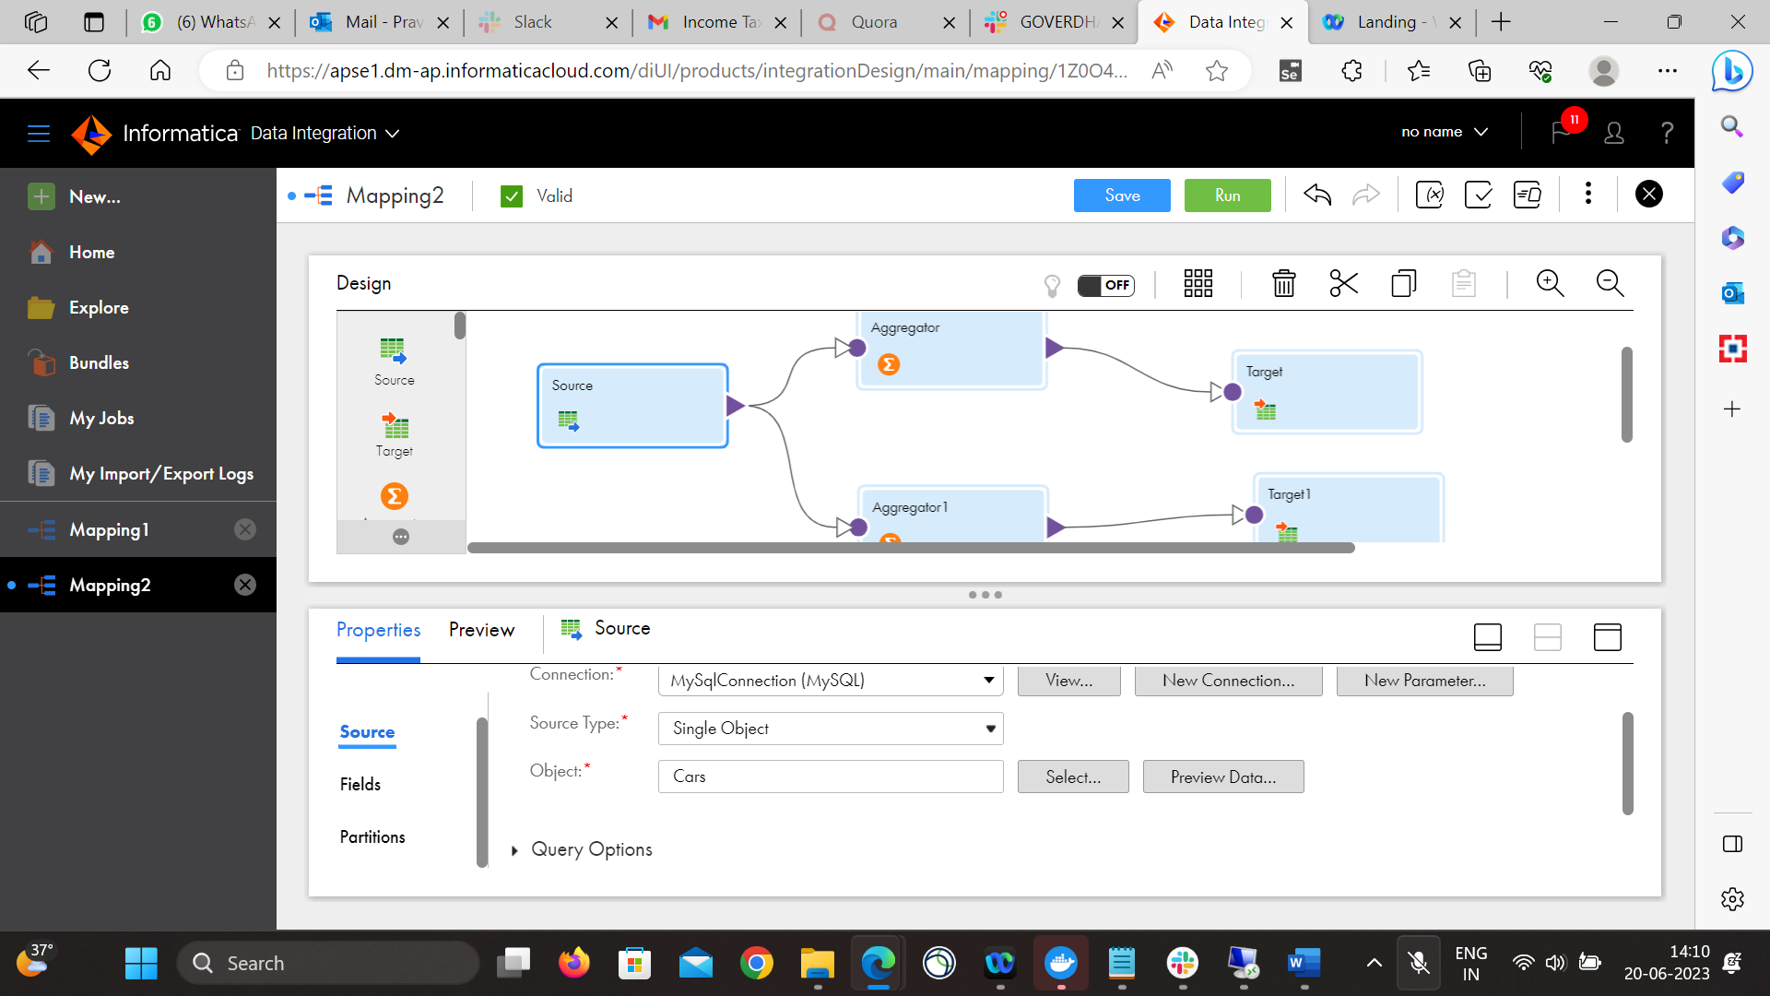

For the Aggregator1, we have selected the Groupby ‘Car_Name’
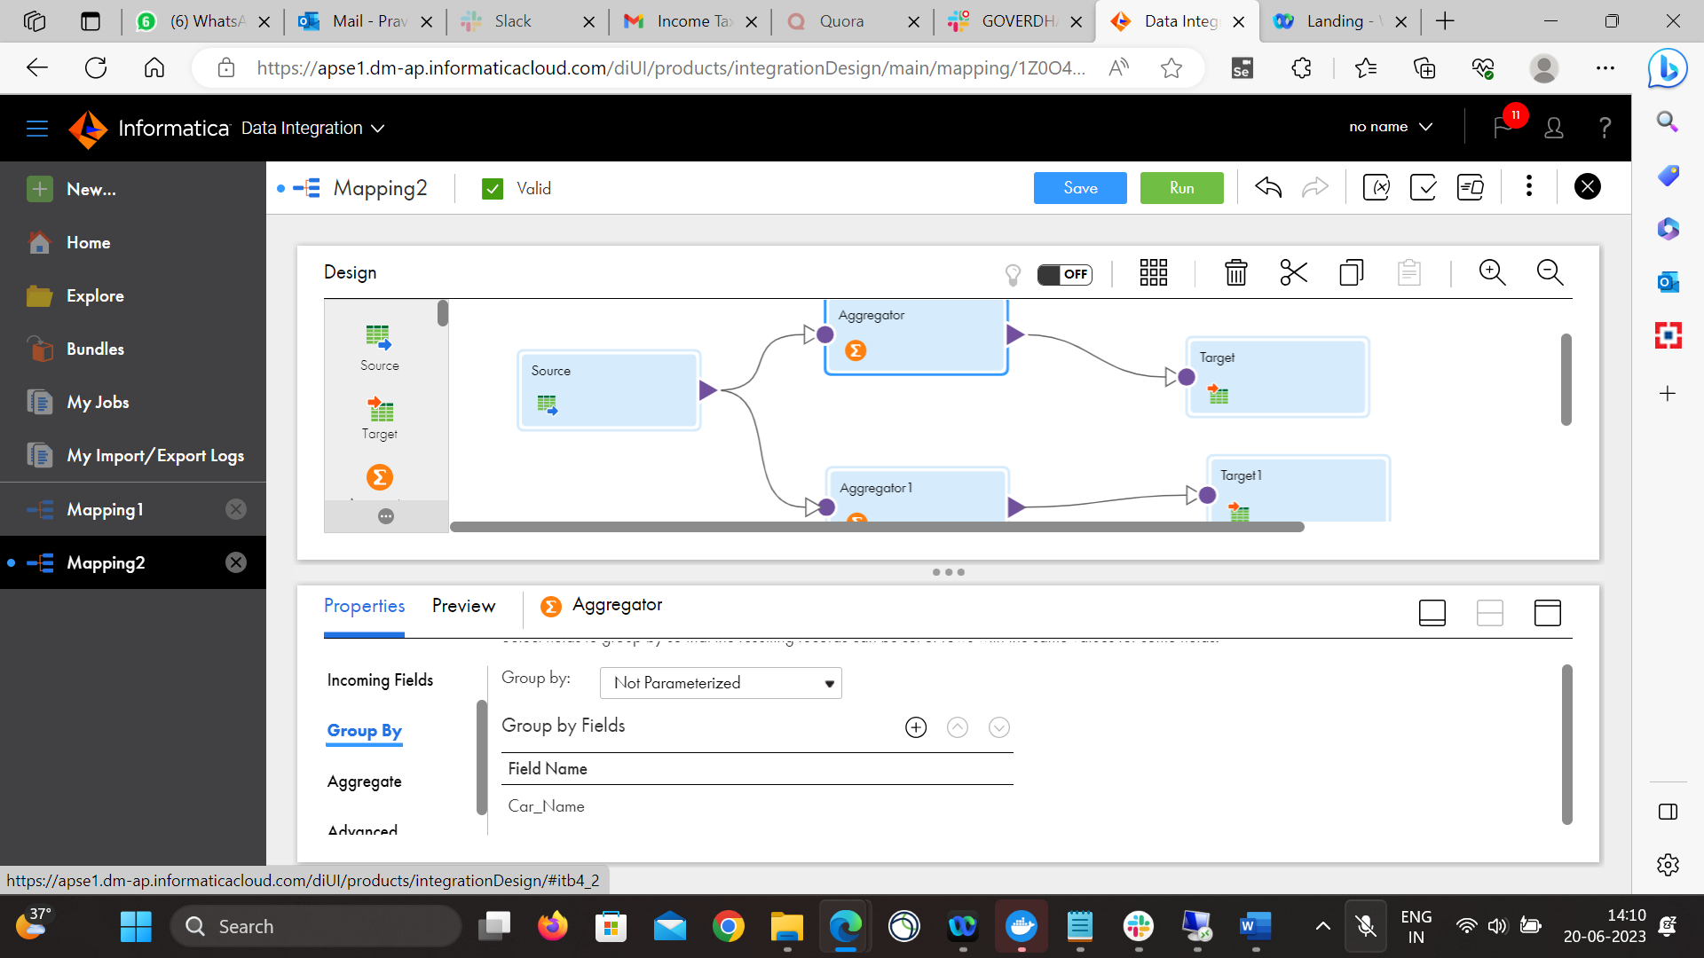

Under Aggregate section, given the expression Max(Car_Price)
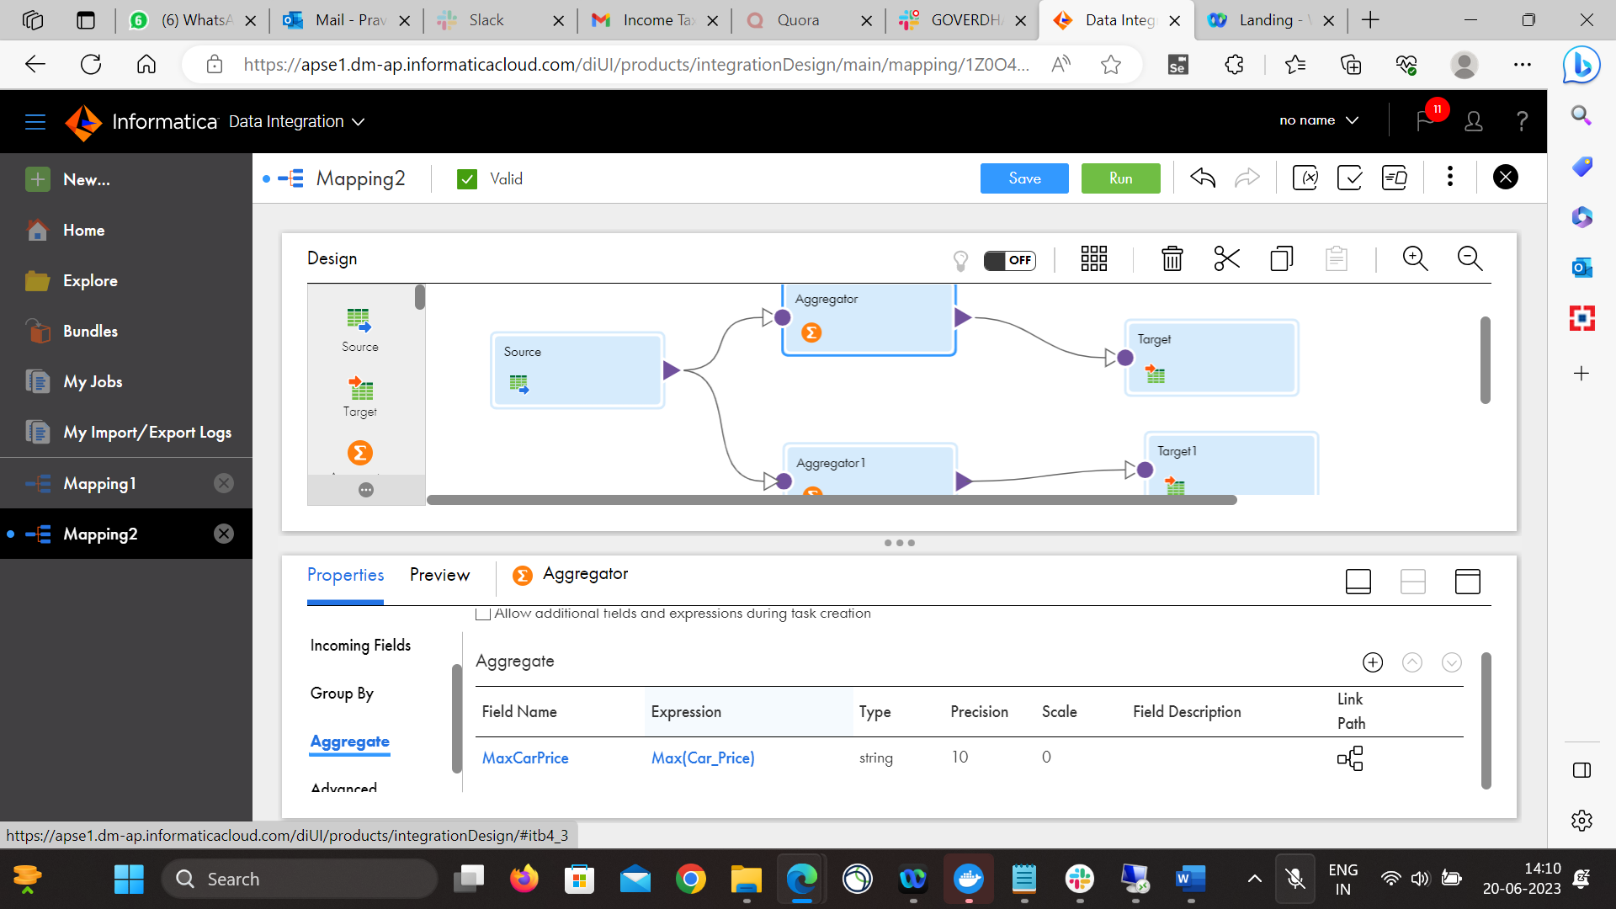

For Aggregate2, need to calculate the min price, so again Group By field as Car_Name
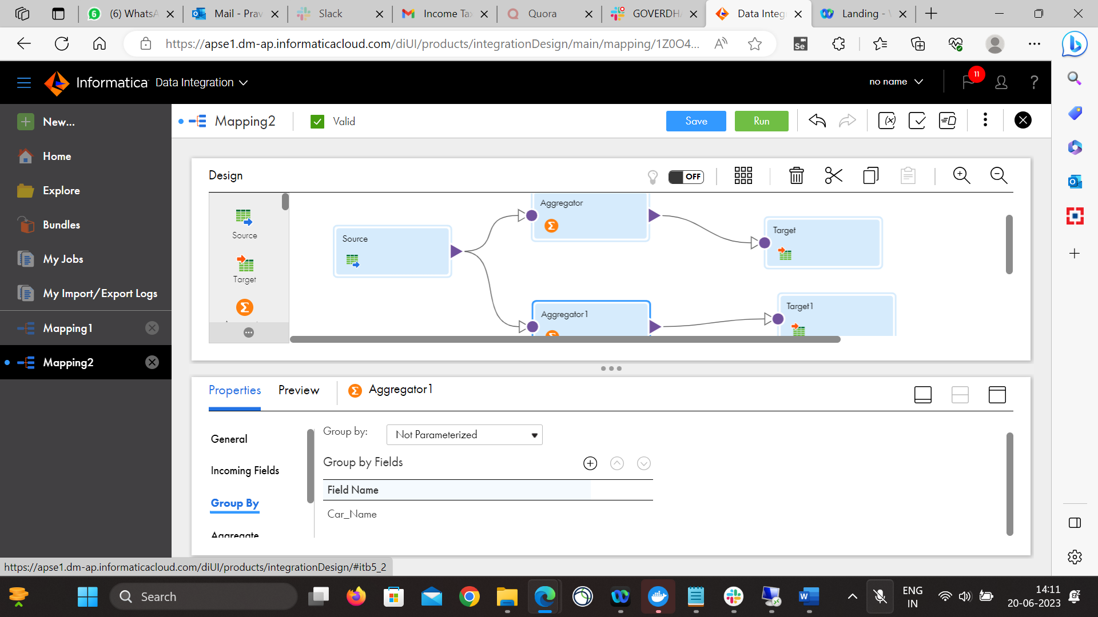

Under Aggregate section, given the expression as Min(Car_Price) since needs to be calculated Minimum car price
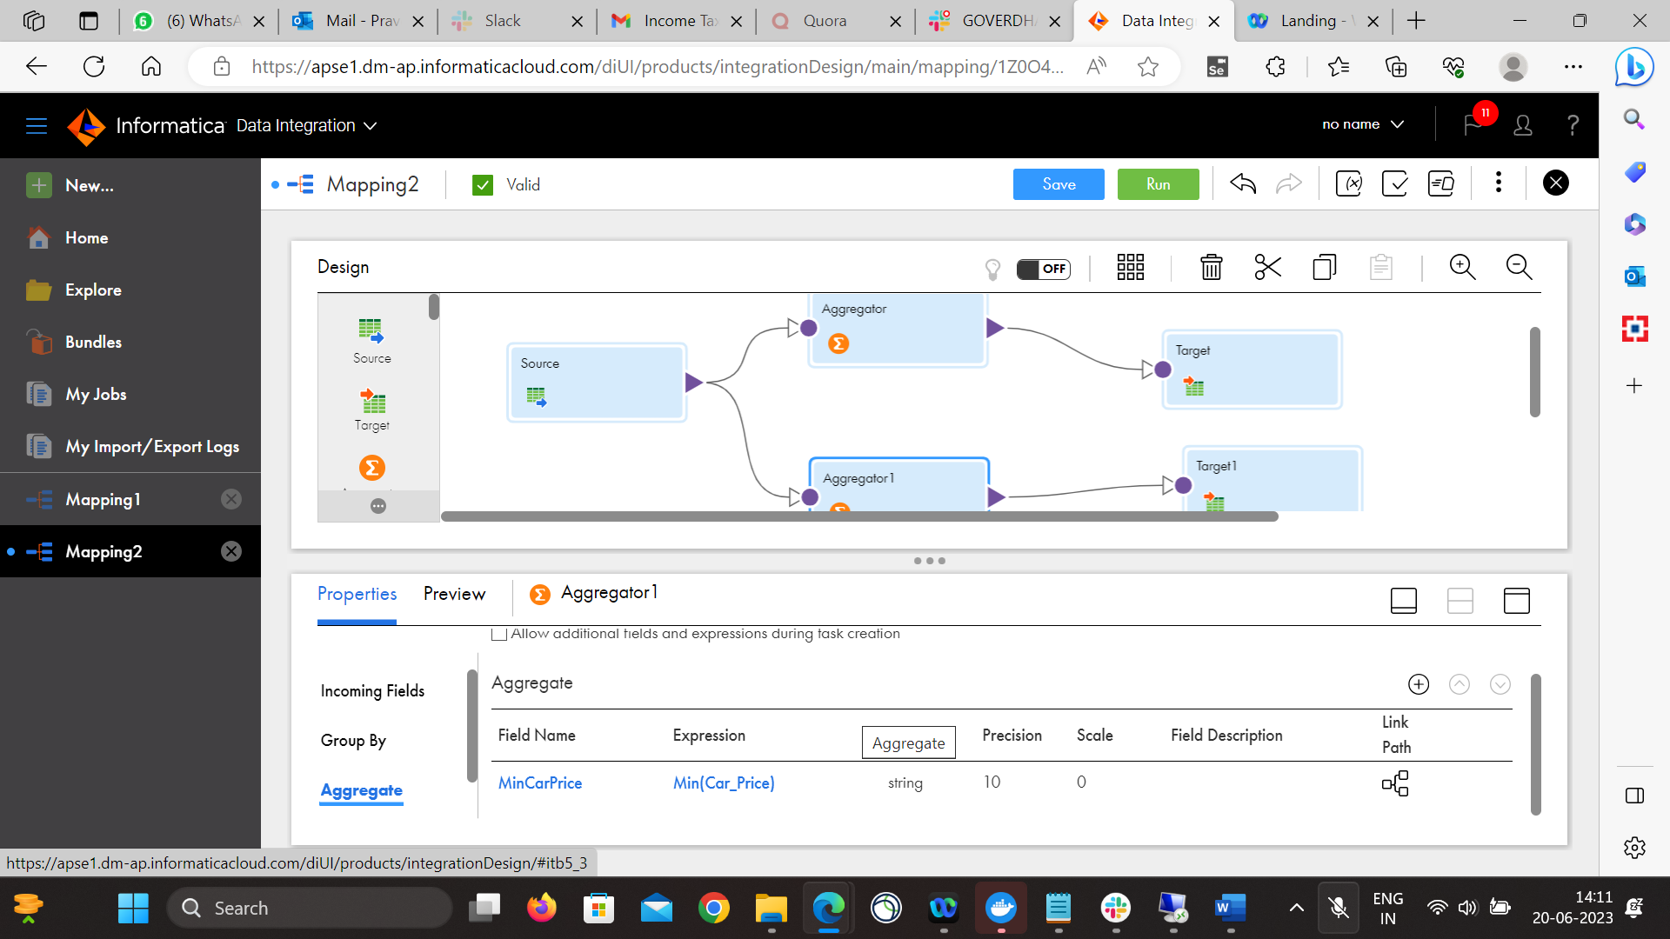

Under Target1, selected MySql connection, and selected the table ‘Cars_Max_Praveen’, which was newly created for output purpose and selected the operation ‘insert’ for inserting the data in the output table.
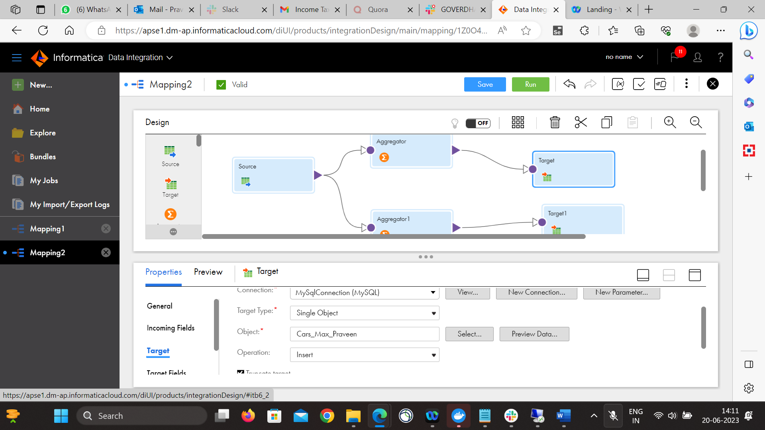

Selected the Target2, and given the MySql connection, and selected the table ‘Cars_Min_Price’, which was newly created for output purpose and selected the operation ‘insert’ for inserting the data in the output table.
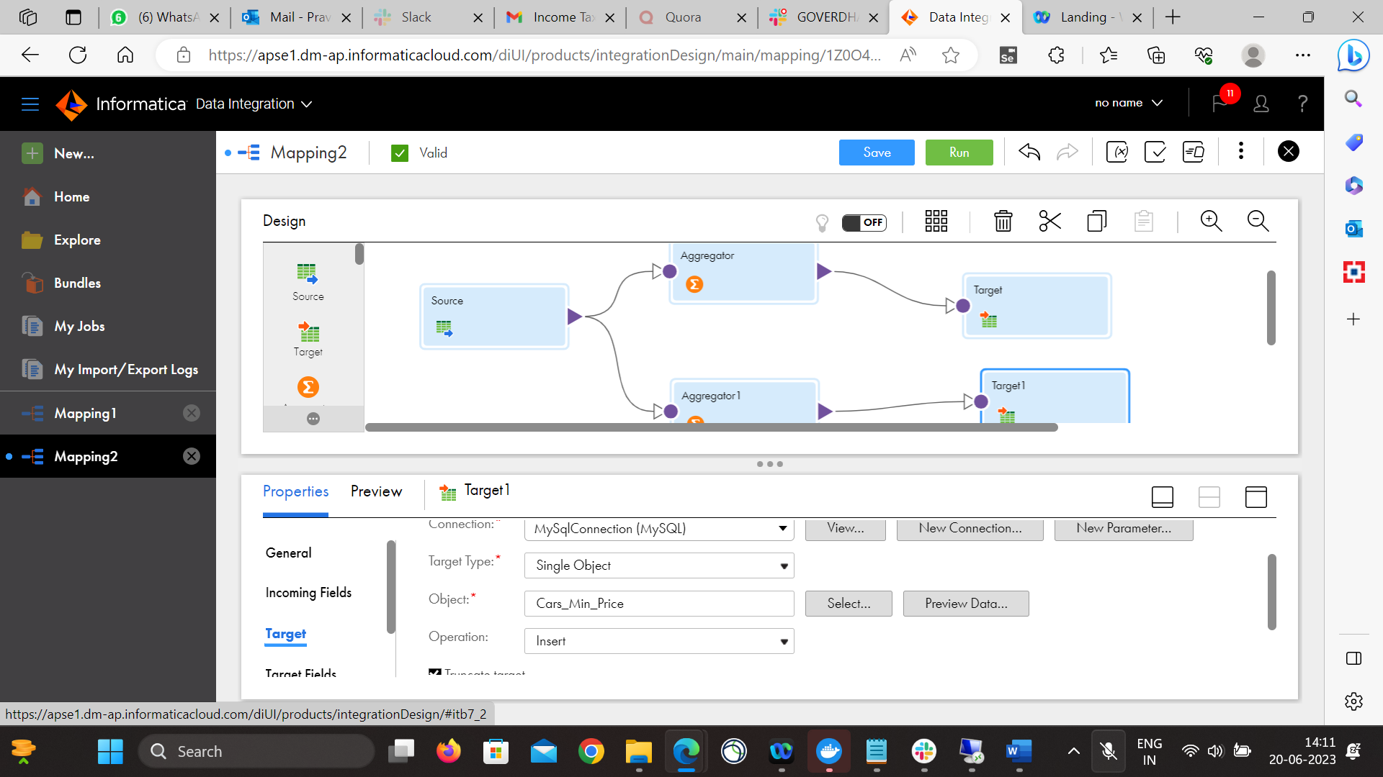

The above job ran successfully and below is the screen shot with instance name Mapping2-6, where 40 rows got processed, 20 rows for Max Price and 20 rows for Min price of Cars.
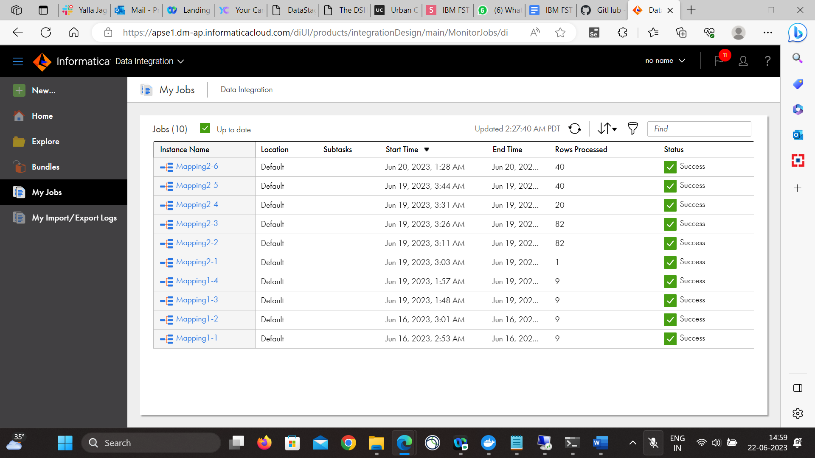

The output log is downloaded and attached to the activity.

